AEM TASK DAY-3

**1. Create the Author Component Structure**

Create a new component under:

/apps/myTraining/components/content/author

Inside the author component create 3 fields

* **Author Name**

**Name:** authorName

**Type:** nt:unstructured

**Properties:**

* + sling:resourceType=granite/ui/components/coral/foundation/form/textfield
  + fieldLabel = Author Name
  + name = ./authorName
  + required = true
* **Author Bio**

**Name: authorBio**

**Type:** nt:unstructured

**Properties:**

* + sling:resourceType=granite/ui/components/coral/foundation/form/textarea
  + fieldLabel = Author Bio
  + name = ./authorBio
  + required = true
* **Date of Birth**

**Name:** dob

**Type:** nt:unstructured

**Properties:**

* + sling:resourceType = granite/ui/components/coral/foundation/form/datepicker
  + fieldLabel = Date of Birth
  + name = ./dob
  + required = true

Structure of the dialogue:

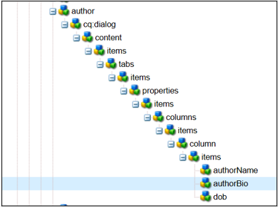

Component display:

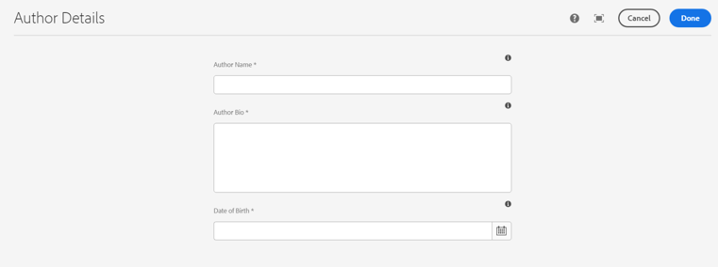

**Fetch Values Using HTL**

Inside author.html, use:

<div class="author">

<h1>${properties.authorName}</h1>

<p>${properties.authorBio}</p>

<strong>${properties.dob}</strong>

</div>

**What is dialog validation?**

Dialog validation ensures that mandatory fields are filled before saving. Set required = true in the dialog nodes.

**What is ExtraClientLibs?**

extraClientLibs is used to include additional client-side libraries in dialogs.

To create a custom extraClientLib, add:

{

"categories": ["custom-author-dialog"],

"dependencies": [],

"js": { "jsFiles": ["./dialog.js"] },

"css": { "cssFiles": ["./dialog.css"] }

}